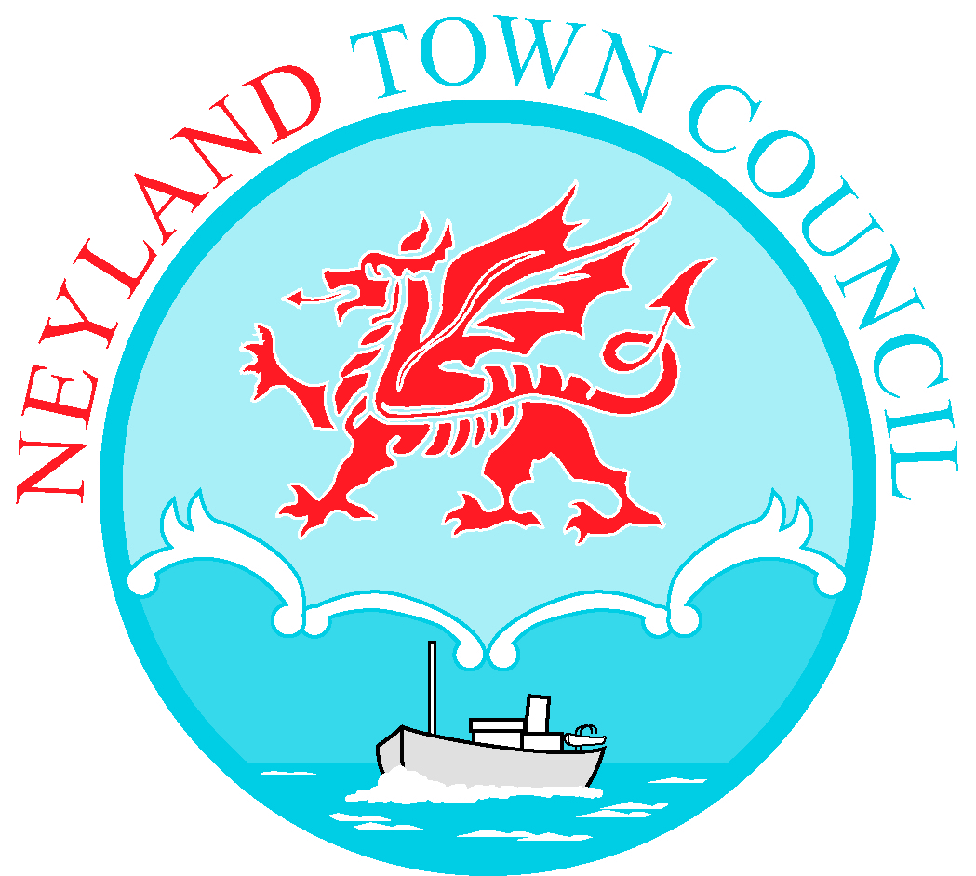

TO: All Members of Neyland Town Council 28th September 2023

Dear Councillor,

You are hereby summoned to attend an Ordinary Meeting of Neyland Town Council to be held on Tuesday 3rd October, at 7.00pm at Neyland Community Hub. If you require a link to attend the meeting virtually, please email townclerk@neyland.org.uk by no later than 12.00pm on Tuesday 3rd October.

Yours sincerely,

Libby Matthews
Town Clerk/RFO

AGENDA
- To receive apologies for absence.
- To receive Declarations of Interest from Members regarding the business to be transacted.
- Representation by public (limited to 15 minutes)
- To approve the minutes of the Ordinary Meeting of Council held on 04.09.2023.
- Matters Arising
- To approve the minutes of the Extraordinary Meeting of Council held on 13.09.2023.
- Matters Arising
- To discuss the budget discrepancy and make alterations if needed.
- To discuss an increase in the budget for Training
- To discuss all Member’s having an Enhanced D.B.S certificate – Cllr A Phelan
- A proposal to adopt the practice of having a monthly agenda item listing matters carried forward from previous meetings until a conclusion is reached – Cllr M Harry
- A proposal to contact Hywel Dda University Health Board for clarification on what the actual provision is for NHS dental services in Pembrokeshire, considering Quay Street Dental Practice ending treatment for NHS patients – Cllr M Harry
- Payments to be approved.
- Clerk’s report.
- Mayor’s update.
- Deputy Mayor’s update.
- Exchange of information at the discretion of the Mayor.
- Date of next meeting: 6th November 2023

